**BOUNDARY VALUE ANALYSIS**

In boundary value testing, we work around the boundaries of the range. Let us suppose, we have a job portal that requires applications from a particular age group of people as mentioned below in Figure 1. Here the acceptable range of values lies from 18 to 56. Initially two categories are decided, valid and invalid. In the valid range, lies all the integer values from 18 to 56 whereas in the invalid range lies all the values below 18 and above 56. This analysis encourages testing to be done for extreme values 17, 57 as error is likely to occur near these points in equivalence partitioning.

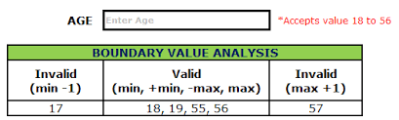

Figure 1 Boundary Value Analysis representation

KEY FEATURES OF BOUNDARY VALUE ANALYSIS

1. Extreme values matter more than inside values.
2. Used with equivalence partitioning, where categories of valid and invalid values are decided.
3. Different values testing: instead of testing at random values, boundary values like minimum, maximum, just inside, and just outside values are considered for testing. For example in the above case, testing will be done for values 17, 18, 56 and 57.

This analysis is a part of black box testing where we are not concerned about the functionality of the system instead we are motivated to get our desired outcome depending on our requirement analysis. The input is tested with extreme values for desired output.